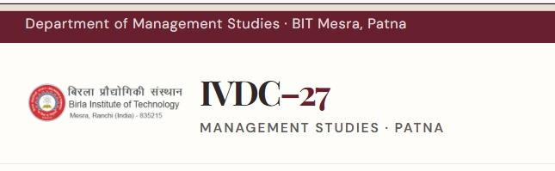
Fix: instead of 27, show 2027
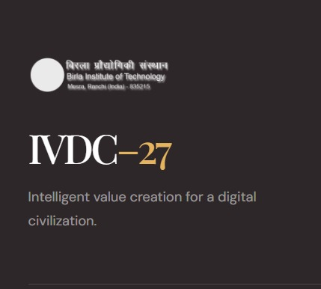
BIT logo, n 2027
Linkdn link not working
For mobile use...the UI format must be improved
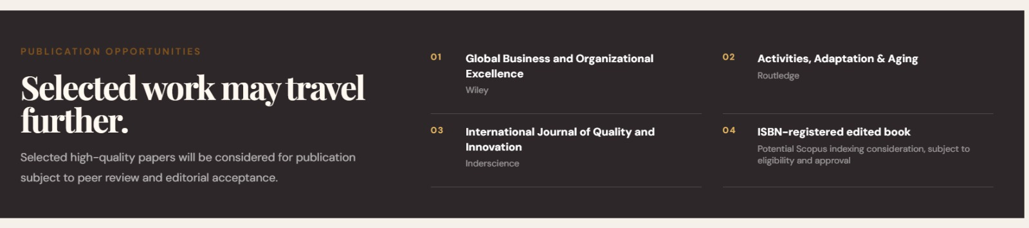
ADD: All accepted extended abstracts will be published in the conference proceedings book with an ISBN.
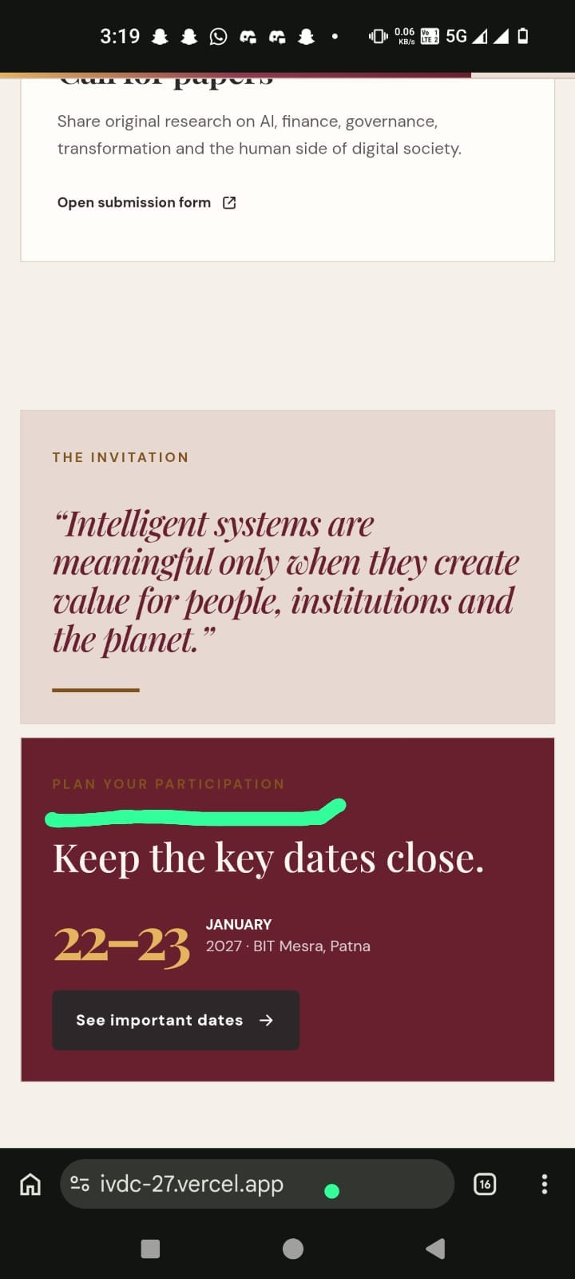The text is darker colour than the background.
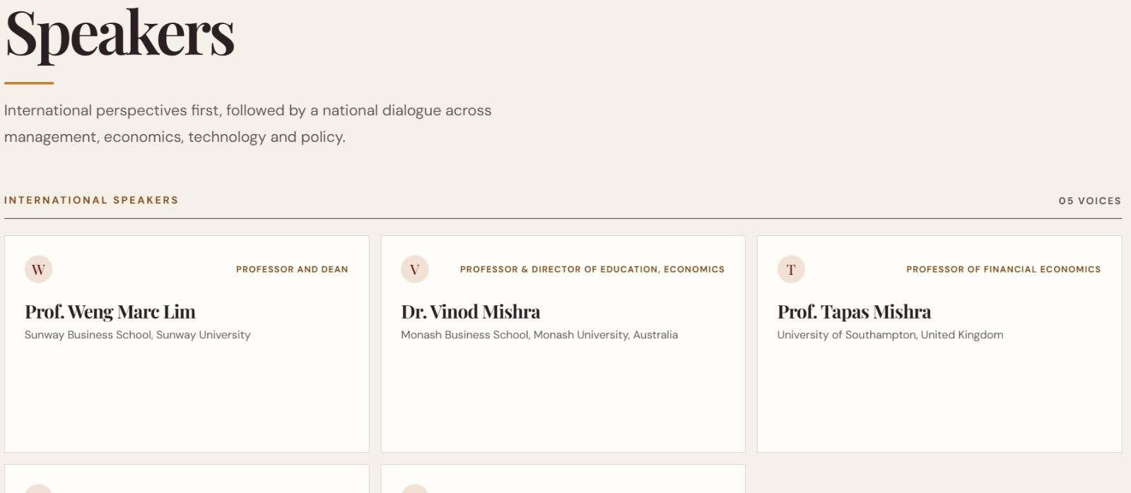take the pics from the internet, and insert pics of all speakers,
similarly pics for them: 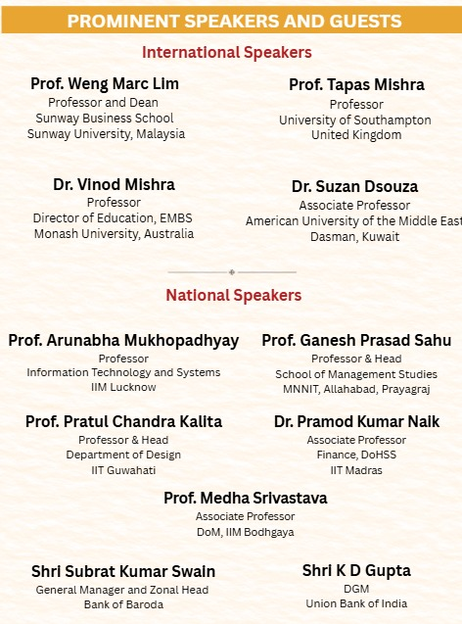
Updated speakers
Please correct accordingly
remove the department directory
in call for paper add this
